**CHAPTER 4**

**SYSTEM DESIGN**

**4.1 Architecture Diagram**

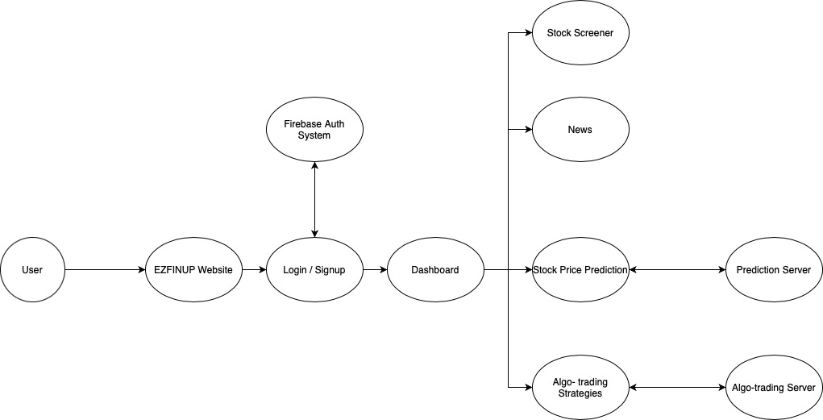

**Fig. 1** Architecture Diagram for the web-app

The entire architecture of the web-app depends on three main modules, Stock Price Prediction, Algo-trading Strategies, and Stock Screener. To handle authentication in our app, Firebase Authentication is used to handle all the auth related processes. Once the user is authenticated by signing in or signing up with a new account, the user is redirected to the dashboard where he can choose to see the price prediction of various stocks, view trading strategies for various stocks or pick a list of stocks according to candlestick patterns using our stock screener. News related to stocks can also be viewed from the dashboard.

**4.2 Sequence Diagram**

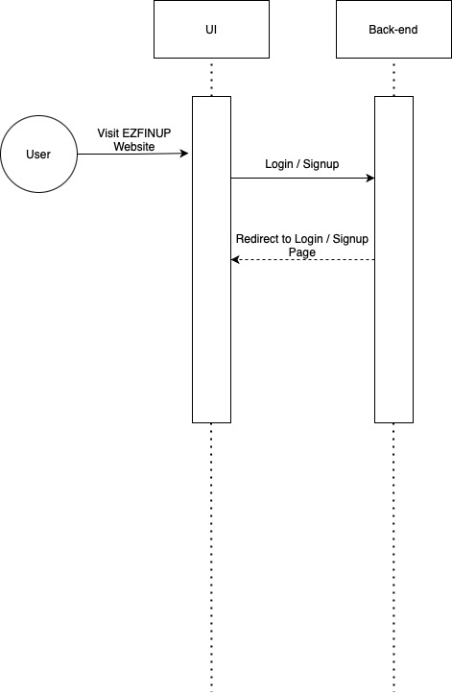

**Fig. 2** Sequence Diagram for Homepage of the web-app

Once the user reaches the homepage, the user has to login/signup to access the exclusive features of the web app. Onclick of the login navigation link in the homepage, the user is redirected to the login page.

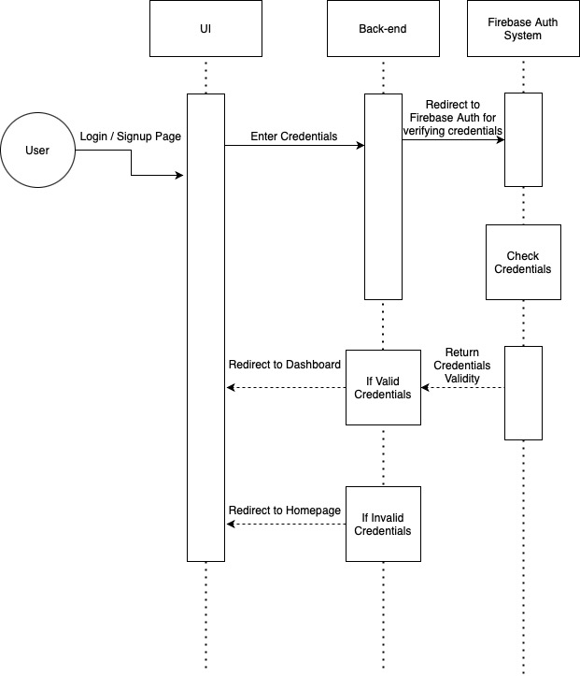

**Fig. 3** Sequence Diagram for Login and Signup module

The user in the login page, enters the credentials in the login form and submits it. The backend server takes these credentials to the Firebase auth system for validating the credentials entered by the user and responds to the backend regarding the authenticity of the credentials and redirects to dashboard if the credentials are valid. If not, the user is redirected back to the login page to enter valid credentials.

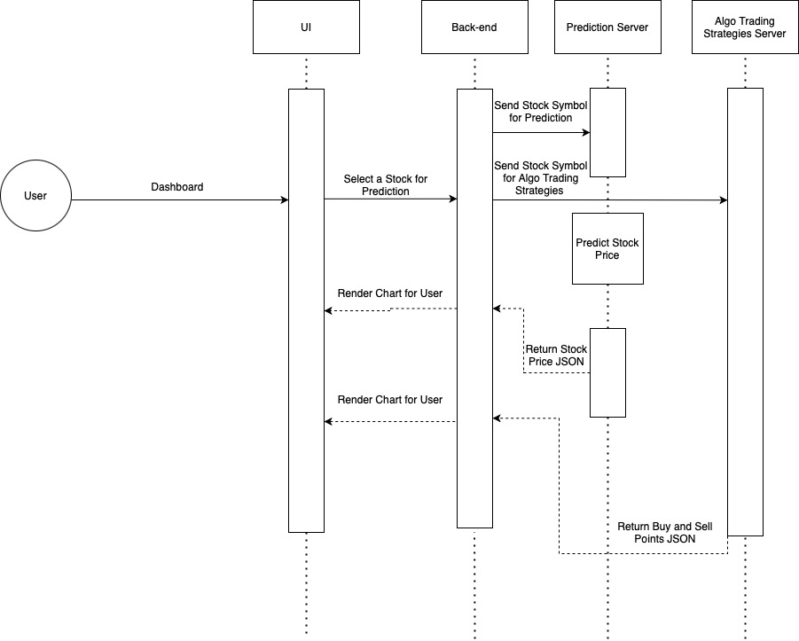

**Fig. 3** Sequence Diagram for Prediction and Algo-Trading Strategies

When a stock is selected by the user to view the prediction and algo-trading strategies, the backend sends the stock symbol (TICKER) to the backend, which then sends requests to the algo-trading server as well as the prediction server, to do the respective tasks. These servers respond with JSON data to the backend which then sends these to the UI to render as charts for good understanding and data-visualization for the user.

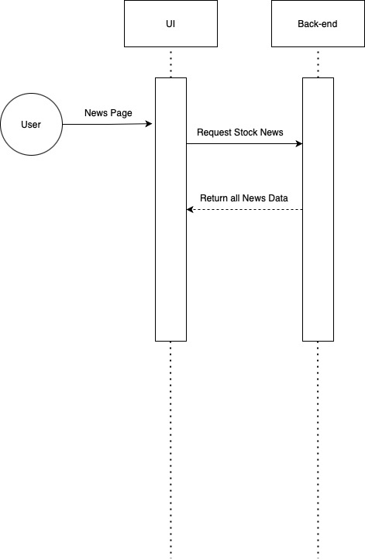

**Fig. 4** Sequence Diagram for Stock News module

When the user requests to view the stock news from the dashboard, the user is redirected to the news page where the backend fetches all the news from various sources and presents it to the user.

**4.4 Activity Diagram**

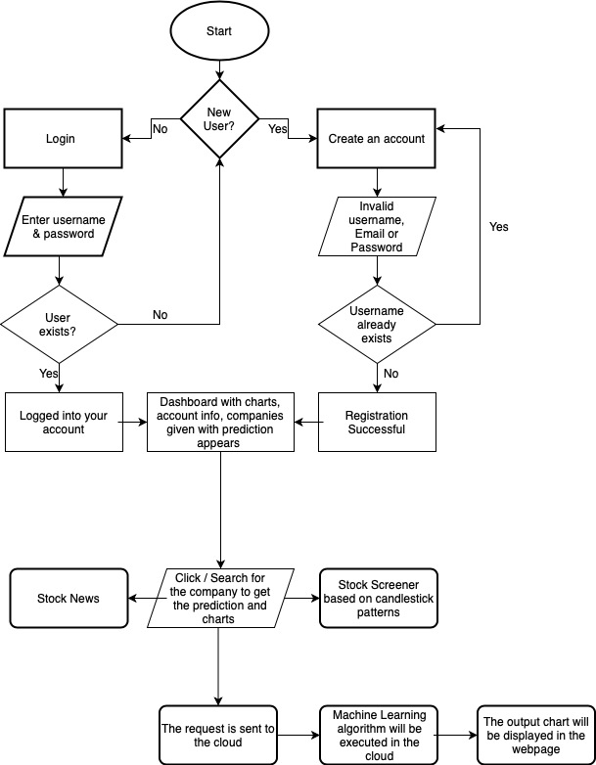

**Fig. 5** Activity Diagram of the Stock Prediction web-app

The activity diagram shows the various activities a user can do in the web-app. A user can login/signup to the application, see his dashboard from where he can see the price prediction for various stocks, see algo-trading strategies, stock news and also filter stocks based on candlestick patterns. The dashboard is the key component of the entire web-app which acts as an access point for all the other features of the web-app.

**4.3 Use Case Diagram**

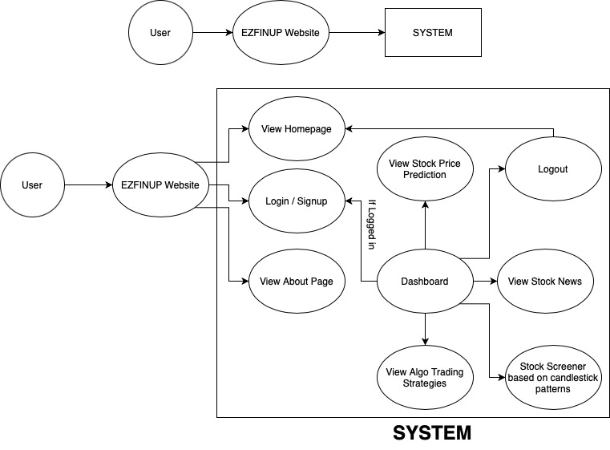

**Fig. 6** Use Case Diagram of the entire web-app

The user is presented with various modules like login/signup, algo-trading strategies, stock screener, stock price prediction and stock news. These are the various use cases which the user is presented with inside the web-app. A brief description of these modules are discussed in the upcoming chapters.